A STUDY ON MARKETING STRATEGIES ADOPTED BY TIMES OF INDIA

INDEX
S.I. No. | CONTENT
1. | INTRODUCTION
2. | OBJECTIVES OF THE STUDY
3. | LIMITATIONS OF THE STUDY
4. | REVIEW OF LITERATURE
5. | COMPANY PROFILE
6. | RESEARCH METHODOLOGY
7. | DATA ANALYSIS AND INTERPRETATION
8. | FINDINGS
9. | SUGGESTIONS
10. | CONCLUSION
11. | BIBLIOGRAPHY
12. | ANNEXURE

LIST OF TABLES
S.NO. | TITLE OF THE TABLE
7.1 | Table showing age wise classification
7.2 | Table showing gender wise classification
7.3 | Table showing professionals
7.4 | Table showing time of subscription
7.5 | Table showing customer expectation
7.6 | Table showing newspaper design and presentation
7.7 | Table showing overall experience of TOI
7.8 | Table showing satisfaction level
7.9 | Table showing easy to find customer need in TOI
7.10 | Table showing quality and condition of the product
7.11 | Table showing overall rating for customer service of TOI
7.12 | Table showing understand concern and issue of the customer
7.13 | Table showing time taken by TOI to answer initial request
7.14 | Table showing recommendation of TOI newspaper to others
7.15 | Table showing distribution channel of TOI newspaper
7.16 | Table showing recommendation of brand to others
7.17 | Table showing positive experience
7.18 | Table showing awareness about the promotional techniques of TOI newspaper
7.19 | Table showing promotional activities of TOI
7.20 | Table showing reliability level of TOI
7.21 | Table showing security measures adopted by TOI
7.22 | Table showing marketing strategy of TOI
7.23 | Table showing impact of marketing and advertising activities

INTRODUCTION

Marketing is the lifeblood of any business organisation. In today's highly competitive and dynamic business environment, the success of a company largely depends on how effectively it markets its products or services. A well-defined marketing strategy helps an organisation focus its resources on the best opportunities, increase sales, and achieve a sustainable competitive advantage.
Marketing strategy refers to a long-term, forward-looking approach that involves analysing the internal and external environment, formulating market-oriented strategies, and implementing them to achieve organisational goals. It serves as the foundation of any marketing plan and includes decisions related to target markets, positioning, product mix, pricing, distribution, and promotion. Marketing strategies are not static; they are dynamic and interactive, requiring continuous scanning of the market, competitors, and customer preferences.
The concept of marketing strategy has evolved significantly over time. According to Philip Kotler, a marketing strategy lays out target markets and the value proposition to be offered based on an analysis of the best market opportunities. Michael Porter emphasised that strategy is about creating a unique and valuable position by performing activities different from those of rivals. These perspectives highlight the importance of having a clear and focused marketing strategy to survive and thrive in competitive markets.
There are different types of marketing strategies, including push strategy and pull strategy. A push strategy involves promoting products to wholesalers and retailers, encouraging them to push the product to end consumers through discounts, free trials, and other incentives. A pull strategy, on the other hand, focuses on advertising and promoting products directly to customers, creating demand that pulls the product through the distribution channel. Many successful companies use a combination of both strategies to maximise their market reach and sales.
The Times of India (TOI) is one of India's oldest and most widely read English newspapers. Founded in 1838 as The Bombay Times, it has grown into a media conglomerate under The Times Group, with a daily circulation of over 3.1 million copies. TOI has successfully adapted to changing market conditions by expanding into television, radio, digital media, and mobile applications. A significant portion of its revenue comes from advertisements, making effective marketing strategies crucial for its continued success.
This study aims to examine the marketing strategies adopted by The Times of India, understand customer perception, analyse sales promotion techniques, and identify how TOI maintains its market leadership. The research is based on primary data collected from 50 respondents and secondary data from various sources. Statistical tools such as Chi-square, F-test, T-test, and correlation have been used to analyse the data and draw meaningful conclusions.
Through this project, an effort has been made to understand how a traditional print media company like TOI continues to stay relevant and competitive in the digital age by using innovative and effective marketing strategies.

OBJECTIVES OF THE STUDY

>PRIMARY OBJECTIVE
To study the marketing strategies adopted by Times of India.

>SECONDARY OBJECTIVES
To measure the customer perception about Times of India.
To understand the various sales promotion strategies of Times of India.
To identify the marketing strategies used by Times Of India to maintain its market share.
To suggest appropriate marketing strategies to gain a competitive advantage
LIMITATIONS OF THE STUDY

Time factor is the main limitation of the study.
The research has been centred to only 50 customers rather than millions of people.
Some of the customers are not interested in giving accurate information about the product and the service.
This study is based on the figure available, and the information given by the customer.
The sample size was not enough to reach any exact conclusion.

COMPANY PROFILE
THE TIMES OF INDIA
The Times of India (TOI)

The Times of India newspaper was founded 178 years ago, it is the largest English newspaper in India with a daily circulation of 3184727 number of copies. It was first published in Mumbai with the name "The Bombay Times" which was edited by J.E Brenan under the orders of RAOBAHADUR Narayan. Now it has expanded into every other type of media (TV, radio, internet, mobile phones) with an estimated revenue of US $ 1.4 billion in 2015 generated from audiences spread across the globe. 70 percent of the money generated in the business comes from the advertisements.

NAME OF THE COMPANY: TIMES OF INDIA (ΤΟΙ)
ADDRESS: The Times of India RMD Magazine cell, 10, Darya Ganj, New Delhi -110002
TYPE OF ORGANIZATION: Newspaper and Magazine
FREQUENCY: Daily Circulation
TELEPHONE NUMBER: +91 11 23302000
OFFICIAL WEBSITE: http://timesofindia.indiatimes.com/
HEADQUARTERS: 7 Bahadur Shah Zafar Marg, New Delhi, Delhi 110002
CIRCULATION: 3,184,727 Daily

POLITICAL ALIGNMENT: Conservative
OWNER AND PUBLISHER: The Times Group
EDITOR-IN-CHIEF: Jaideep Bose

Key Businesses: -
- Newspaper
- Magazines
- TV channels
- Advertisements
- Investments
- Mobile apps

Newspaper and magazines: -
- With 13 newspapers and 18 magazines, it is India's largest publisher, having twenty-six printing centres across India
- The Times of India English edition is the world's most widely circulated newspaper.
- The Economics Times is a well-known newspaper among business readers; it is the number one Business newspaper in India.
- In collaboration with the BBC, they have some of the best magazines available in India. Filmfare is India's top-selling magazine.

TV Channels: -

- MN+HD
- ROMEDY Now
- ROMEDY Now H
- Movies Now
- Movies Now HD
- MNX
- MNX HD
- ET Now
- Zoom
- Times Now
- Times Now HD
- Mirror Now

Advertisements: -

- Newspaper and magazines are the best source of offline advertising, I know people who have done advertising in newspaper or magazines and had success, as it is the best way to reach large number of audience, thousands of ads are given in newspaper every day, people who want to grow their business faster usually uses this kind of paid advertising
- Times of India have advertising contracts with most of the major companies in India and even airports
Other Activities: -
- Sponsoring music and movies
- Sponsoring games
- Cotching
- Event Management
- Financial Service

History:
The Times of India issued its first edition 3 November 1838 as The Bombay Times and Journal of Commerce. The paper published Wednesdays and Saturdays under the direction of RAO BAHADUR Narayan Dinanath VELKAR, a Maharashtrian Reformist, and contained news from Britain and the world, as well as the Indian Subcontinent. J.E. Brennan was its first editor. In 1850, it began to publish daily editions.
In 1860, editor Robert Knight (1825-1892) bought the Indian shareholders' interests, merged with rival Bombay Standard, and started India's first news agency. It wired Times dispatches to papers across the country and became the Indian agent for Reuters news service. In 1861, he changed the name from the Bombay Times and Standard to The Times of India. Knight fought for a press free of prior restraint or intimidation, frequently resisting the attempts by governments, business interests, and cultural spokesmen and led the paper to
[national prominence. In the 19th century, this newspaper company employed more than 800 people and had a sizable circulation in India and Europe.

1838
On November 3, 1838 the main release of The Bombay Times and Journal of Commerce were distributed, reflecting fundamentally the business group of Bombay. It was a weak production. Edited by Dr J.E Brennan.

1850
The capital was increased and the weekly circulation was turned into daily circulation

1859
A merger took place between Bombay standards and chronicles of western to form "Bombay Times Standard"

1861
The Times of India was formed by the amalgamation process to give it national statues

1892
The joint stock company by the name Bennett, Coleman & Co. Ltd. (BCCL) was formed by new additur T.J Bennett by entering into partnership with F.M Coleman

1907
The demand increased by five folds when editor Stanley increased the dead line from 5 pm to 12 midnight and decreased the price from 4 anna to 1 anna of a newspaper

1946
Seth Ramakrishna bought the company and gave it an Indian ownership
[10:48 pm, 04/04/2026] ishu: 1947

For the first time, special Sunday edition was introduced and a new Hindi edition called Nav Bharat Times was launched in Delhi

1948
The company was sold to SAHU Shanti Prasad who was the son in law of Ramakrishna Dalmia, SAHU Shanti was also the first chairman of the company

1950
It was Introduced in Delhi for the first time.

1952
Best Selling magazine of India was launched "Filmfare"

1959
They captured the female segment with the launch of FEMINA

1961
One of the best Busines sselling magazine was launched "The Economics Times"

1962
Introduction of Maharashtra Times

1965
They entered event business with FEMINA Miss India contest

1988
150 years was completed by Times of India, to congratulate the Indian government released special stamp.

1997
They entered music industry with Times of India

1999
Website of India Times was launched
Two million copies were circulated giving them milestone

2001
It became number one in Delhi and went all colour, Radio Mirchi was broadcasted across the nation

2003
The first lifestyle TV channel was launched by Times of India in 2003 and a website for employment opportunity was also made available

2005
A website for searching a partner for a marriage was introduced

2006
Times now was broadcasted on TV, Radio Mirchi network was listed on stock exchange and went fourteen times oversubscribed, they also dominated the Karnataka printing business by acquiring Karnataka based company Vijay Anand printers Ltd.

2007
Economics times was introduced in Marathi language for the first time, and Bangalore mirror, Ahmedabad mirror was also introduced, they also made another milestone by circulating 3 million copies which made them the largest English daily newspaper across the globe.

2008
UK based radio channel "Virgin Radio" was acquired and Economics time (Hindi) was launched.

2009
First-class business channel was launched

2010
They came up with a concept called brand capital which was like a barter system, though brand capital they got shares in company's stocks and gave them advertisement space for a certain period. Highdefinition movie channel was launched (MoviesNow)

2011
In Kannada they introduced spiritual weekly paper

2012
New editions for Kerala, Visakhapatnam and Raipur were started.

2013
Kolhapur edition was started.

2014
India's most trusted brand with a ranking of 174. CRICBUZZ. was acquired.

Mission Statement of Times of India:

"Create & build brands with differentiated content to capture relevant audiences and market the value of these to advertisers to help them sell and strengthen their brands."

Corporate Goals:
Continue to develop innovative products in accordance with our mission statement, adding three products each year. Core Competency and Sustainable Competitive Advantage: A strongly dedicated and innovative product development team. Largest infrastructure for advertising and circulation sales. A strong sales team. Dedicated employees. Strong business strategies. The Times of India has a wide range of brands in different regional languages, which cover a large range of audiences or readers. Today,\/ TOI is India's national newspaper with editions spread across most states, which is complemented by its robust presence in the online domain too through its e-paper.

STRENGTHS:
The world's largest newspaper brand and strong brand image. Easy Brand Recall in a competitive market with numerous dailies; high brand loyalty. Weekly paper called Ascent is widely regarded as an excellent platform and a must-read for potential recruiters to delay circular for advertising and circulation sales. Very good newspaper printing quality.

WEAKNESSES:
Some people have the perception that TOI publishes more celebrity /entertainment news. Very few distribution channels in rural and small cities in India. Less information about the stock market. Late circulation in small cities.
Lack of coverage of useful news for competitive students.

OPPORTUNITIES:
Expanding organised distribution channels in small cities and rural areas. Has a limited presence in Southern India as compared to that of India. Huge opportunity in the Regional Languages space. Better usage and interaction with online and mobile mediums. Personalized newspaper editions. Value addition space media. Digital

EDITIONS AND PUBLICATIONS:
The Times of India is published by the media group Bennett, Coleman & Co. Ltd. The company, along with its other group of companies, known as The Times Group, also publishes Ahmedabad Mirror, Bangalore Mirror, Mumbai Mirror, Pune Mirror; Economic Times; ET Panache (Mumbai, Delhi and Bangalore on Monday to Friday) and Times of India ET Panache (Pune and Chennai on every Saturday); EISAMAY, (a Bengali daily); Maharashtra Times, (a Marathi daily);
NAVBHARAT Times, (a Hindi daily).
The Times of India has its editions in major cities such as Mumbai, Agra, Ahmedabad, Allahabad, Aurangabad, Bareilly, Bangalore, Belgaum, Bhopal, Bhubaneswar, Coimbatore, Chandigarh, Chennai, Dehradun, Delhi, Gorakhpur, Gurgaon, Guwahati, Gwalior, Hubli, Hyderabad, Indore, Jabalpur, Jaipur, Jammu, Kanpur, Kochi, Kolhapur, Kolkata, Lucknow, Ludhiana, Madurai, Malabar, Mangalore, Meerut, Mysore, Nagpur, Nashik, Navi Mumbai, Noida, Panaji, Patna, Pondicherry, Pune, Raipur, Rajkot, Ranchi, Shimla, Surat, Thane, Tiruchirapally, Trivandrum, Vadodara, Varanasi, Vijayawada and Visakhapatnam.

TIMES GROUP NETWORK:
Speaking Tree
A spiritual network intended to allow spiritual seekers to link spiritual seekers with established practitioners.
Health me up
A health, diet, and fitness website.
CRICBUZZ
In November 2014, Times Internet acquired CRICBUZZ, a website focused on cricket news.
REVIEW OF LITERATURE

>According to David Aaker and Michael K. Mills (2001) "An overriding directional concept that sets out the planned path." It shows the long-term, forward-looking approach to planning with the fundamental goal of achieving a sustainable competitive advantage. It involves an analysis of the company's strategic initial situation prior to the formulation, evaluation, and selection of market - oriented competitive position that contributes to the company's goals that contributes to the company's goals and marketing objectives.

➤According to Alfred D. chandler (2002), "Strategy is the determination of the basic long-term goals and objectives of an enterprise and the adoption of the course of action and the allocation of resources necessary for carrying out these goals" It states that the market strategy of the firm is reacting to its environment, deploys its principal resources and Marshalls its main efforts in pursuit of its purpose.

➤ According to Michael E. Porter (2004) "creation of unique and value positive involving a different set of activities and a company is strategically positioned performs different set of activities from its rivals" It describe that he has taken this view on the basis of the assumption that many companies believe that they can establish a long lasting competitive advantage by performing similar activities better than their competitors. But today, competitors can rapidly copy the operationally - effective companies using benchmarking and other tools, thus diminishing the advantage of operational effectiveness.

➤According to S. Jain (2006)"The pattern of major objectives, purposes and goals and essential policies and plans for achieving those goals, stated in such a way as to define what business the company is in or is to be in" It expressed the marketing concept holds that the planning and coordination of all the business activities around the primary goal of satisfying customer needs is the most effective means to attain and sustain a competitive advantage and achieve company objectives over time

➤According to William F. GLUECK, (2008) "A market strategy is a unified, comprehensive, and integrated plan relating the strategic advantages of the firm to challenges of the environment. It is designed to ensure that the basic objectives of the enterprise are achieved". It determines the major plans which are to be undertaken and allocates resources to make the firm more advantageous and lead to designing the basic objectives of the enterprise to be achieved.

➤ According to Orville C. Walker, jr. James. D (2012). "A Market strategy is a fundamental pattern of present and planned objectives, resource deployments, and interactions of an organization with markets, competitors, and other environmental factors " It defined as that a strategy specify (1) what (objectives to be accomplished), (2) where (on which industries and product -markets to focus), and (3) how (which resources and activities to allocate to each product - market to meet the environmental opportunities and threats and to gain a competitive advantage.

➤According to Michael Porter, (2012) "Essentially a formula for how a business is going to compete, what its goals should be and what policies will be needed to carry out these goals. "It represents the most basic level of strategic marketing and addresses deceptively simple questions: where are we now? Where are we going? and how are we going to get there? by applying the formulation of the strategy.

➤According to Philip Kotler & Kevin Keller(2013) "The marketing strategy lays out target markets and the value proposition that will be offered based on an analysis of the best market opportunities." It determines the market strategy plan is the process of defining the marketing strategy and how the company shall implement the marketing techniques.

➤According to Kenichi Ohmae, (2013)"reserved for actions aimed directly at altering the strengths of the enterprise relative to that of its competitors... Perfect strategies are not called for. What counts is... performance relative to competitors." It expresses the primary strategic responsibility of any manager to look outward continuously to keep the firm or business in step with changes in the environment.
RESEARCH METHODOLOGY

Research Methodology refers to the various methods and techniques involved in the process of research. The information required for the preparation of the report is collected through two sources viz;
1. Primary Data
2. Secondary Data

PRIMARY DATA:
The data collected for a purpose for a particular problem in original is known as -Primary Data. It consists of all the answers first hand.

Sources of primary data:
The sources are divided into basically two types: internal and external. Internal source analysis is referred to as sales analyses. The external sources include the salesman, dealers and consumers. On the basis of requirement the information is collected from anyone or all of the sources.

Methods of collecting Primary data:
The collection of information is referred to as the primary method. There are various methods in which primary data can be adopted and thus can be broadly classified as survey methods and experimental methods.

Survey methods:
The survey is a complex operation, which requires some technical Knowledge. Survey methods are of personal character and depending on the information required

There are six major types of surveys.
Facts Survey - Collects only facts.
Opinion Survey - Opinions in various problems are collected.
Attitude Survey - Determines the attitudes of the consumers.
Future inventions Survey - Used to discover future trends.
The Reason why Survey - Seeks to determine why a person has done something to do in future. One survey may contain several types since it may give several better kinds of information. The various kinds of surveys are carried out through different methods. Usually three general methods are used to conduct a survey.

2. SECONDARY DATA:
The data collected from the public sources i.e., not originally Collected for the first time is called secondary data. Suppose we want to know the population of the city, we need not go house to house to collect the same but can refer to the census report.
Sampling technique: Sampling technique adopted for the study is convenient random sampling,

Sample Size: 50 subscribers of Times Of India Newspaper
Statistical tools: Statistical tools applied used are
Percentage analysis
correlation
Chi-square
F - test
T-test

PERCENTAGE ANALYSIS
This is another form of component diagram. The components are not the actual value but the percentage of the whole. In this diagram, bars, cones etc. are of different heights since the Totals may be different in the case of data having subdivisions, percentage diagram will be more appealing than component diagram.
Formula = NO. OF RESPONDENTS * 100
No. of samples

CHI-SQUARE
In examining the relationship between two or more variables, the first step is to set up a frequency table which is called a contingency table. In general, a contingency table is of r*c size, where r indicates the number of rows and c represents the number of columns. With the help of this technique, we can test whether or not two or more variables are associated or not.

Formula: X 2 = (Oi - Ei )2 /E

F- TEST
An F-Test is any statistical test in which the test statistic has an F distribution under the null hypothesis. It is most often used when comparing statistical models that have been fitted to a data set in order to identify the model that best fits the population from which the data were sampled.
Formula: S12=x 2 /n¹- (2x/n1)²
S22 = Σy 2 / n² - (Σy /n2) 2

T-TEST
The t-test is a statistical hypothesis test in which the test statistic follows a student's t- distribution under null hypothesis. It is commonly applied when the test statistic follows a normal distribution if the value of the scaling term is unknown and is replaced by an estimate based on the data. It can be used to determine if two sets of data are significantly different from each other or not.
Fórmula: x – y
S 1/N1 +1/N2

CORRELATION
Correlation is a statistical measure that indicates the extent to which two or more variables fluctuate together. A positive correlation indicates the extent to which those variables increase or decrease in parallel; a negative correlation indicates the extent to which one variable increases as the other decreases.
Formula: = N∑dxdy−(∑dx)(∑dy)
N∑dx2−(∑dx)2​⋅N∑dy2−(∑dy)2​

DATA ANALYSIS & INTERPRETATION
DATA ANALYSIS & INTERPRETATION

Table1

Age-wise classification
Age | No of respondents | Percentage
Less than 25 | 20 | 40%
25 - 35 | 9 | 18%
35 - 45 | 15 | 30%
45 - 55 | 6 | 12%
TOTAL | 50 | 100%

INTERPRETATION:
From the above table, it indicates that 40% of the respondents are less than 25 years of age, 18% of the respondents are from 25-35, 30% of the respondents are between 35-45 years of age, 12% of the respondents are from 45-50.

Chart 1
AGE-WISE CLASSIFICATION

Table 2

Gender wise Classification
Gender | No of respondents | Percentage
Female | 24 | 48%
Male | 26 | 52%
TOTAL | 50 | 100%

INTERPRETATION:
From the above table, it represents that 48% of the respondents are female and 52% of the respondents are male.

Chart 2
GENDER WISE CLASSIFICATION

Male ███████████████████████████████████████
52%
Female █████████████████████████████████████ 48%

Table 3

Profession
Profession | No of responds | Percentage
Student | 10 | 20%
Employee | 35 | 70%
Un employee | 5 | 10%
TOTAL | 50 | 100%

INTERPRETATION:
From the above table, it represents that 20% of respondents are students, 70% of respondents are Employee and 10% of the respondents are not an employee.
Chart 3

PROFESSION

Time period of subscription | No of respondents | Percentage
3 - 6 months | 20 | 40%
6 months - 1 year | 10 | 20%
1 - 3 years | 7 | 14%
3 - 5 years | 3 | 6%
More than 5 years | 10 | 20%
TOTAL | 50 | 100%
Table 4
Time period of subscription

INTERPRETATION:
From the above table, 40% of respondents subscribe for 3-6 months, 20% subscribe for 6 months-yearly, 14% subscribe for 1-3 years, 6% subscribe for 3-5 years, and 20% subscribe for more than 5 years.
Chart 4
TIME PERIOD OF SUBSCRIPTION

3-6 month ███████████████████████████ 40%
6 months-1 year ████████████████████ 20%
1-3 years ██████████████ 14%
3-5 years ██████ 6%
More than 5 yrs ████████████████████ 20%

Table 5

Customer Expectation
Customer Expectation | No of respondents | Percentage
Service | 19 | 38%
Quality | 11 | 22%
Contented | 1 | 2%
Delivery process | 11 | 22%
Other | 8 | 16%
TOTAL | 50 | 100%

INTERPRETATION:
From the above table, 38% of respondents expect Times Of India to improve service and 22% respondents expect to improve both delivery process and quality, 16% of respondents expect Times Of India to improve other services.

Chart 5
CUSTOMER EXPECTATION

Service ████████████████████████████████████████ 38%
Quality ██████████████████████ 22%
Delivery proc. ██████████████████████ 22%
Other ████████████████ 16%
Contented ██ 2%

Table 6

Newspaper design and presentation
Design and Presentation (Rating) | No of respondents | Percentage
1 out of 5 | 7 | 14%
2 out of 5 | 9 | 18%
3 out of 5 | 6 | 12%
4 out of 5 | 13 | 26%
5 out of 5 | 15 | 30%
TOTAL | 50 | 100%

INTERPREATATION:
From the above table, it represents that 14% rate 1 out of 5, 18% rate 2 out of 5, 12% rate 3 out of 5,26% rate 4 out of 5 for newspaper design and presentation and 30% rate 5 out of 5 for newspaper design and presentation.
Chart 6
NEWSPAPER DESIGN AND PRESENTATION

Table 7
Overall experience (Rating) | No of respondents | Percentage
1 out of 5 | 2 | 4%
2 out of 5 | 3 | 6%
3 out of 5 | 5 | 10%
4 out of 5 | 25 | 50%
5 out of 5 | 15 | 30%
TOTAL | 50 | 100%
Overall experience with India Service

Interpretation:
From the above table, 4% rated 1 out of 5, 6% rated 2 out of 5, 10% rated 3 out of 5, 50% rated 4 out of 5, and 30% rated 5 out of 5 for their overall experience with Times of India service. This indicates that the majority of respondents (80%) gave a positive rating of 4 or 5 out of 5, showing that most customers are highly satisfied with the overall service of Times of India.

Chart 7
EXPERIENCE WITH SERVICE

5 out of 5
██████████████████████████████ 30%

4 out of 5
██████████████████████████████████████████████████ 50%

3 out of 5
██████████ 10%

2 out of 5
██████ 6%

1 out of 5
████ 4%

Table 8
Satisfaction Level | No of respondents | Percentage
Highly dissatisfied | 3 | 6%
Dissatisfied | 1 | 2%
Neutral | 10 | 20%
Satisfied | 16 | 32%
Highly satisfied | 20 | 40%
TOTAL | 50 | 100%
Customer Satisfaction with relate to Times Of India

INTERPRETATION:
From the above table, It found that the 34% respondents said it is very easy to find customer need and 30% of respondents said it is easy and moderate to find customer needs, 4% of respondents said it is difficult to find customer need and 2% of the respondents said it is very difficult.

Chart 8
CUSTOMER SATISFACTION LEVEL

Table 9
Easy to find customer need with Times of India

Easy to find the customer needs with TOI | No of respondents | Percentage
Very easy | 17 | 34%
Easy | 15 | 30%
Moderate | 15 | 30%
Difficult | 2 | 4%
Very difficult | 1 | 2%
TOTAL | 50 | 100%

INTERPRETATION:
From the above table, It found that the 34% respondents said it is very easy to find customer need and 30% of respondents said it is easy and moderate to find customer needs, 4% of respondents said it is difficult to find customer need and 2% of the respondents said it is very difficult.

Chart 9

EASY TO FIND NEEDS

Table10
Quality and condition of the product
Quality and condition | No of respondents | Percentage
Highly dissatisfied | 9 | 18%
Dissatisfied | 8 | 16%
Neutral | 5 | 10%
Satisfied | 10 | 20%
Highly satisfied | 18 | 36%
TOTAL | 50 | 100%

INTERPRETATION:
From the above table, 18% of respondents are highly dissatisfied, 16% of respondents are dissatisfied, 10% of the respondents are neutral, 20% of respondents are satisfied and 36% of respondents are highly satisfied with the quality and condition.

Table 10
QUALITY AND CONDITION OF THE PRODUCT

Table 11
Overall rating for customer service
Rating for customer service | No of respondents | Percentage
1 out of 5 | 2 | 4%
2 out of 5 | 5 | 10%
3 out of 5 | 10 | 20%
4 out of 5 | 15 | 30%
5 out of 5 | 18 | 36%
TOTAL | 50 | 100%

INTERPRETATION:
From the above table, 4% of the respondents rate 1 out of 5, 10% of the respondents rate 2out of 5, 20% respondent rate 3 out of 5, 30% of the respondents rate 4 out of 5, and 36% of the respondents rate 5 out of 5 for overall service.

Table 11
OVERALL RATING FOR CUSTOMER SERVICE

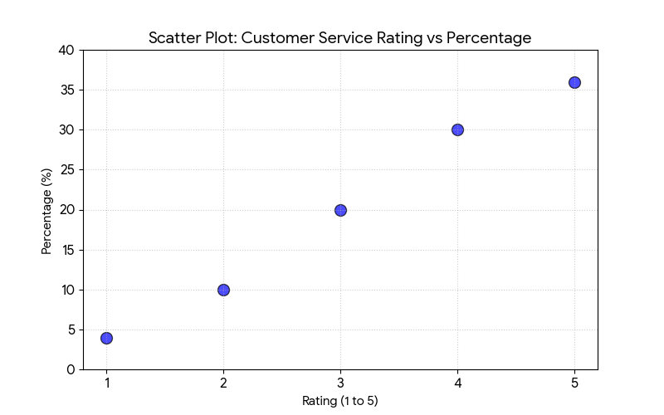

Table 12
Understanding the concerns and issues of the customer | No of respondents | Percentage
Excellent | 22 | 44%
Above average | 13 | 26%
Average | 10 | 20%
Below average | 1 | 2%
Very poor | 4 | 8%
TOTAL | 50 | 100%
Understanding concern and issue of the customer

INTERPRETATION:
From the above table, it represents that 44% of respondents said excellent, 26% of respondents said above average, 20% of the respondents said average, 2% of the respondents said below average and 8% of the respondents said very poor for understanding the concern and issue of the customers.

Chart 12
UNDERSTANDING CONCERN AND ISSUE OF THE CUSTOMER
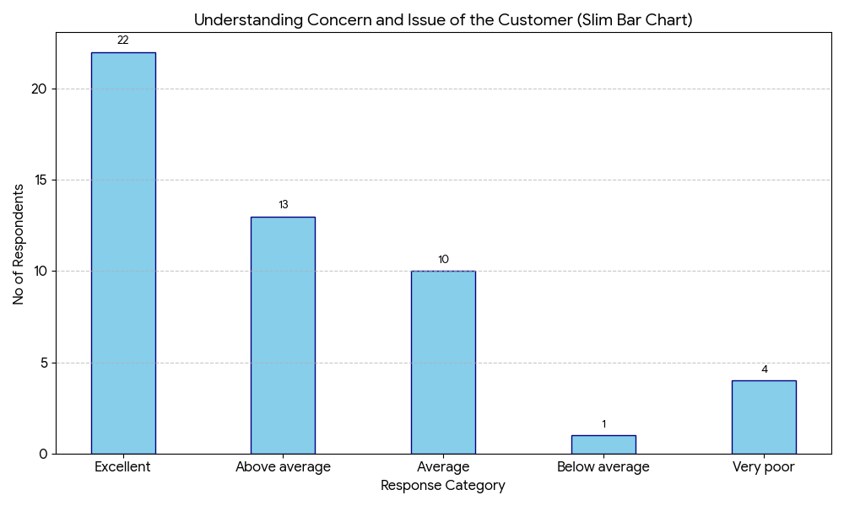

Table 13
Time taken by the TOI to answer the initial request

Time taken by TOI to answer the initial request | No of respondents | Percentage
Much shorter than expected | 17 | 34%
Shorter than expected | 10 | 20%
Expected | 10 | 20%
Much longer than expected | 5 | 10%
Longer than expected | 8 | 16%
TOTAL | 50 | 100%

INTERPRETATION:
From the above table, 34% of respondents said much shorter than expected and 20% of respondents said shorter than expected and expected, 10% of respondents said much longer than expected, 16% of respondents said longer than expected time taken to answer the customer's initial request.

Chart 13
TIME TAKEN BY THE TOI TO ANSWER THE INITIAL REQUEST

Table14
Recommended TOI to others | No of respondents | Percentage
Very likely | 20 | 40%
Likely | 10 | 20%
Probably | 10 | 20%
Unlikely | 7 | 14%
Very unlikely | 3 | 6%
TOTAL | 50 | 100%
Recommendation of Times Of India to others

INTERPRETATION:
The above table shows that 40% of the respondents would recommend to others and 20% of the respondents likely recommend to others, 14% are not recommend to others.

Chart 14
RECOMMENDATION OF TIMES OF INDIA TO OTHERS

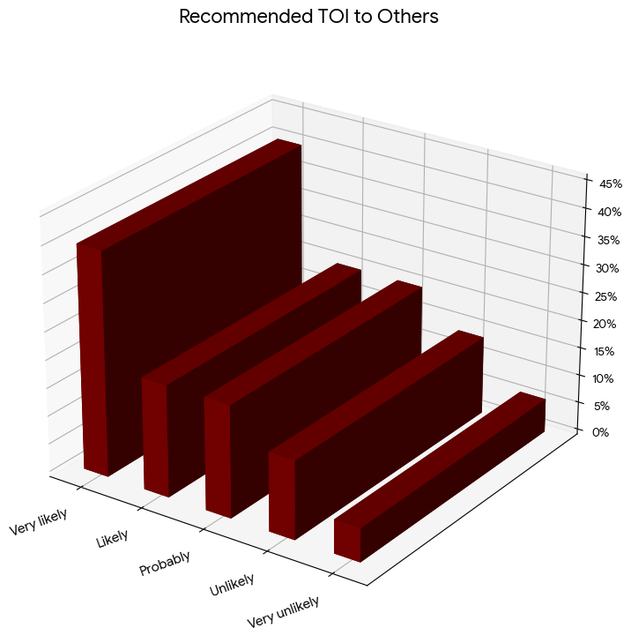

Table 15
Satisfied with the distribution Channel of the TOI newspaper
Distribution channel of TOI | No of respondents | Percentage
Highly dissatisfied | 5 | 10%
Dissatisfied | 5 | 10%
Neutral | 10 | 20%
Satisfied | 12 | 24%
Highly satisfied | 18 | 36%
TOTAL | 50 | 100%

INTERPRETATION:
It is inferred that 10% of respondents are highly dissatisfied and dissatisfied, 20% of respondents are neutral, 24% of the respondents are satisfied36% of respondents are highly satisfied with the distribution channel of Times of India

Table 15
SATISFIED WITH THE DISTRIBUTION CHANNEL OF THE TOI NEWSPAPER

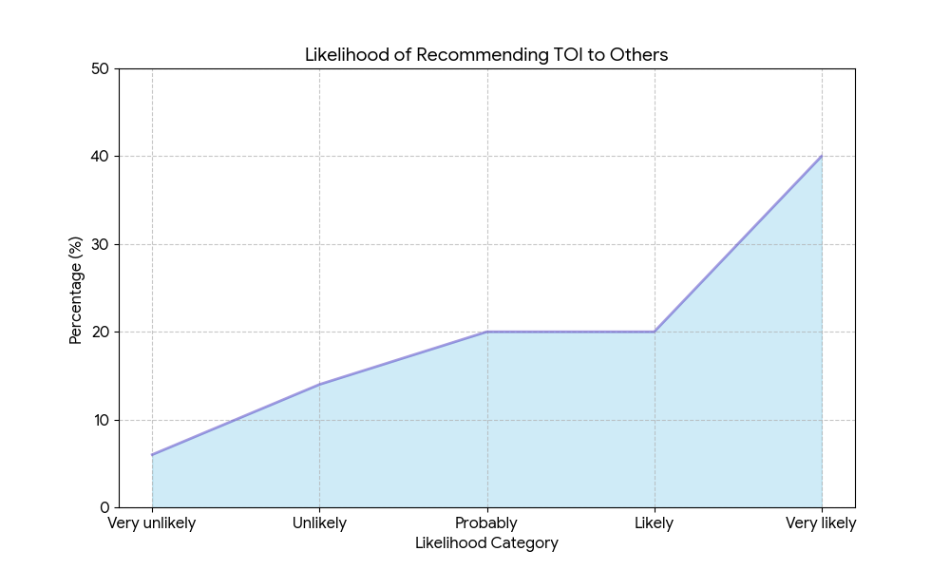

Table16
Positive Experience with Times of India customer service
Positive experience | No of respondents | Percentage
Yes | 36 | 72%
No | 14 | 28%
TOTAL | 50 | 100%

INTERPRETATION:
According to the respondents 72% have said yes and 28% said no to the positive experience with Times of India customer service.

Chart 16
POSITIVE EXPERIENCE WITH TIMES OF INDIA CUSTOMER SERVICE

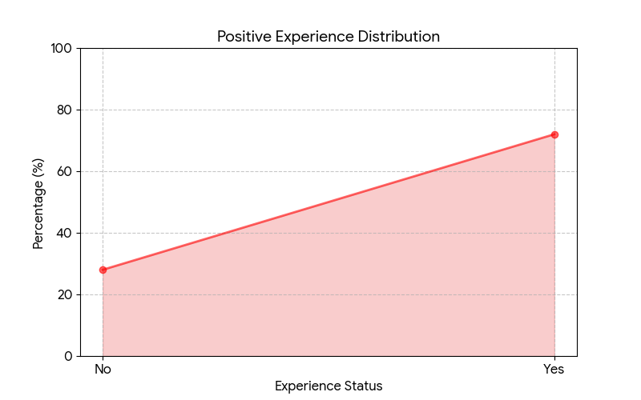

Table 17
Awareness about the promotional activities of TOI newspaper

Awareness about promotional activities | No of respondents | Percentage
Yes | 25 | 50%
No | 25 | 50%
TOTAL | 50 | 100%

Interpretation:
From the above table, 50% of respondents replied Yes and 50% replied No regarding their awareness about the promotional activities of Times of India. This indicates that exactly half of the customers are aware of TOI's promotional activities, while the other half are unaware. This suggests that TOI needs to improve its promotional communication to reach a wider audience.

Chart 17
AWARENESS ABOUT THE PROMOTIONAL ACTIVITIES OF TOI NEWSPAPER

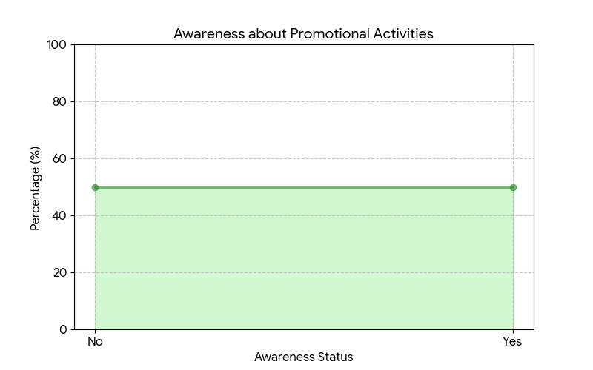

Table 18
promotional activities
Rating | No of respondents | Percentage
Excellent | 25 | 50%
Above average | 10 | 20%
Average | 10 | 20%
Below average | 2 | 4%
Very poor | 3 | 6%
TOTAL | 50 | 100%

INTERPRETATION:
From the above table, indicate that 50% of respondents said excellent, 20% of respondents average and above average, 4% of respondent said below average and 6% of respondent said very poor for the promotional activities of Times of India.
Chart 18
PROMOTIONAL ACTIVITIES

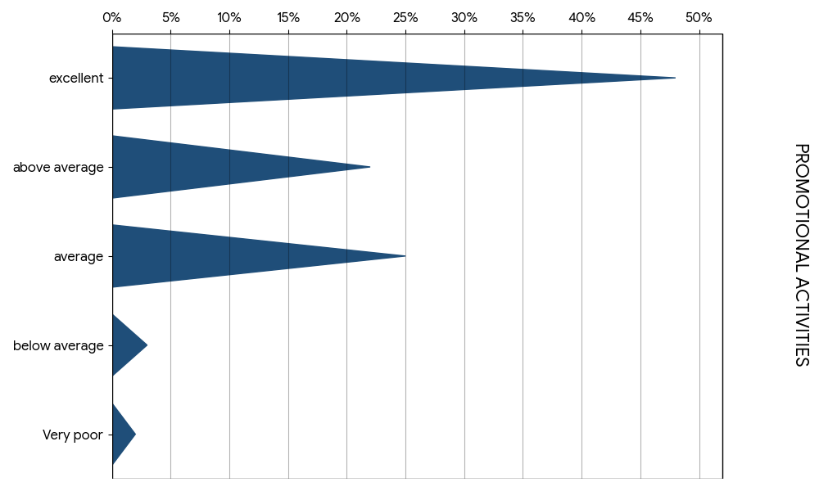

Table 19
Reliability level of Times Of India
Reliability level of TOI | No of respondents | Percentage
Excellent | 20 | 40%
Above average | 15 | 30%
Average | 12 | 24%
Below average | 2 | 4%
Very poor | 1 | 2%
TOTAL | 50 | 100%

INTERPRETATION:
From the above table, it represents that 40% of respondents said excellent, 30% of respondents said above average, 24% of respondent said average, 4% of respondent said below average and 2% of respondents said very poor for reliability level of TOI.

Table 19
RELIABILITY LEVEL OF TIMES OF INDIA

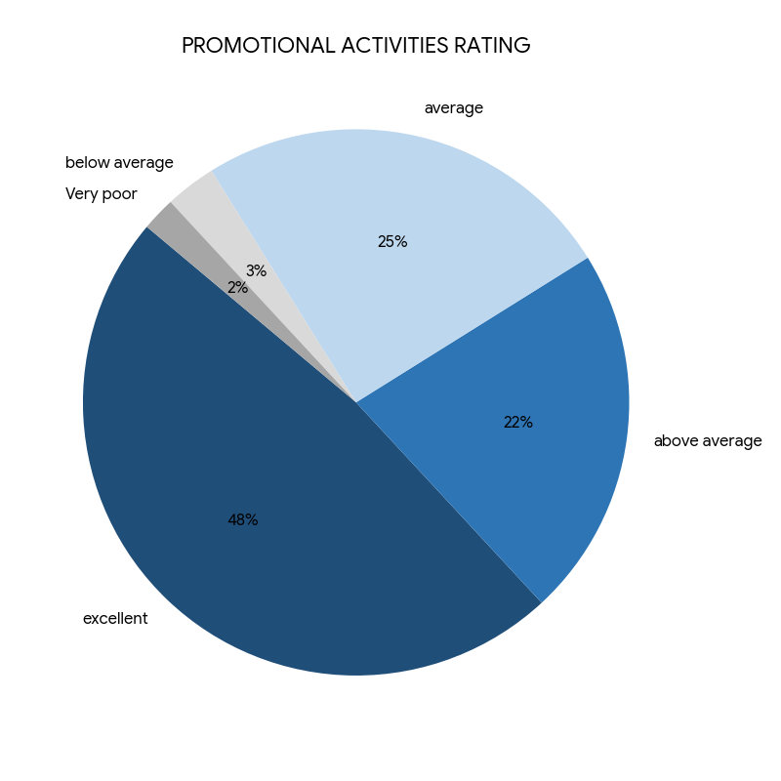

Table 20
Security measures adopted by TOI during covid-19 pandemic
Security measures adopted by TOI | No of respondents | Percentage
Excellent | 23 | 46%
Above average | 12 | 24%
Average | 10 | 20%
Below average | 3 | 6%
Very poor | 2 | 4%
TOTAL | 50 | 100%

INTERPRETATION:
From the above table, it represents that 46% of respondents rated excellent, 24% of respondent rated above average, 20% of respondent rated average, 6% respondent rated below average and 2% of respondents rated very poor for the security measures adopted during covid-19 pandemic.

Chart 20
SECURITY MEASURES ADOPTED BY TOI DURING COVID-19 PANDEMIC
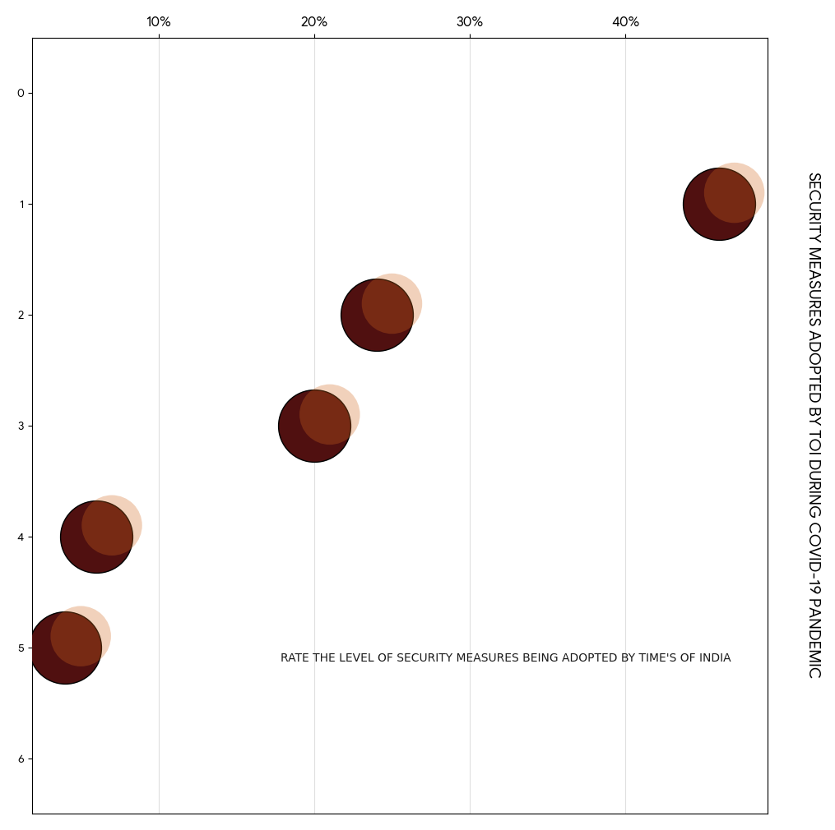

Table 21
Effectiveness of marketing strategy adopted by Times of India
Impact of marketing strategy | No of respondents | Percentage
Excellent | 18 | 36%
Above average | 15 | 30%
Average | 10 | 20%
Below average | 5 | 10%
Very poor | 2 | 4%
TOTAL | 50 | 100%

INTERPRETATION:
From the above table, it represents that 36% respondents rated excellent, 30% respondent rated above average, 20% respondent rated average, 10% respondent rated below average, and 4% respondent rated very poor for the effectiveness of marketing strategies adopted by TOΙ.
Chat 21
EFFECTIVENESS OF MARKETING STRATEGY ADOPTED BY TIMES OF INDIA

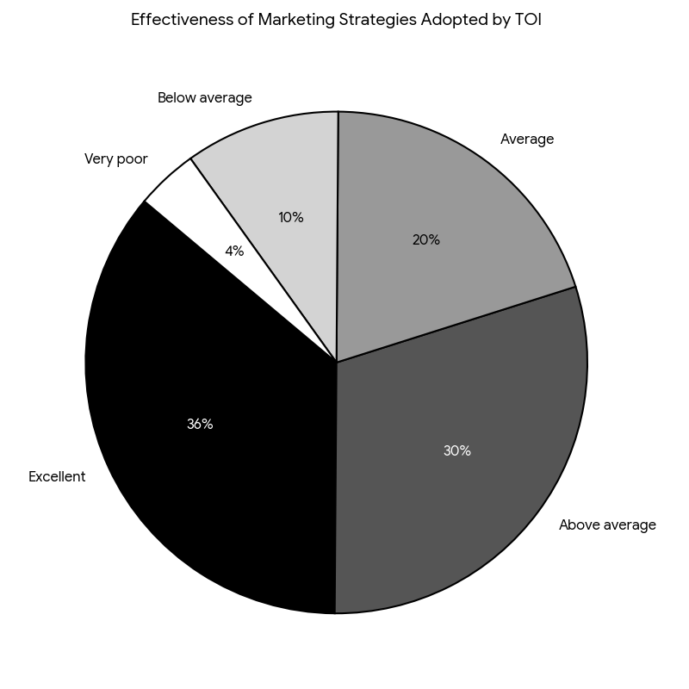

Table 22
Marketing and advertising activities of TΟΙ
Impact of marketing and advertising activities | No of respondents | Percentage
Excellent | 26 | 52%
Above average | 8 | 16%
Average | 14 | 28%
Below average | 1 | 2%
Very poor | 1 | 2%
TOTAL | 50 | 100%

INTERPRETATION: 6It is inferred that 52% respondent rated excellent, 16% respondent rated above average, 28% respondent rated average, 2% respondent rated below average and very poor for the marketing and advertising activities of Times of India.

Chart 22
MARKETING AND ADVERTISING ACTIVITIES OF TΟΙ
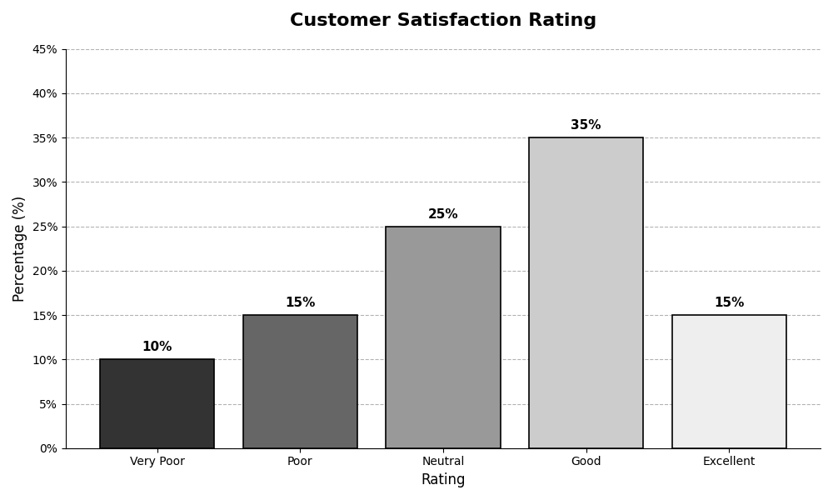

STATISTICAL TOOLS

CORRELATION

HO: There is an association between the satisfaction level of the quality and condition and the overall rating for service.

H1: There is no association between the satisfaction level of the quality and condition and the overall rating for service.

OBSERVED VALUE
PARTICULAR

SATISFACTION LEVEL OF QUALITY AND CONDITION | OVERALL RATING FOR SERVICE
22 | 17
13 | 10
10 | 10
1 | 5
4 | 8

CALCULATION OF CORRELATION
X | Y | X² | Y² | XY
22 | 17 | 484 | 289 | 374
13 | 10 | 169 | 100 | 130
10 | 10 | 100 | 100 | 100
1 | 1 | 1 | 25 | 5
4 | 4 | 16 | 64 | 35
ΣX = 50 | ΣY = 50 | ΣX² = 770 | ΣY² = 578 | ΣXY = 644

FORMULA
R= N∑dxdy - ∑dx∑dy / √N∑dx² - (∑dx)² × √N∑dy² - (∑dy)²

R = correlation between two variables
X = first variable
Y = second variables

= 5(644)-50(50)
5770-(50)² 5578-502

= 3220-2500
3850-2500 2890-2500

= 720
350 – 390
= 720
(36.742) (19.748)

= 720 = 0.99
725.58

CONCLUSION:
The correlation between the overall rating for service Y and the satisfaction level of quality and condition X is positive.

CHI – SQUARE
TIME GAP TO FIND THE NEEDS OF THE CUSTOMER AND PROFESSIONAL.
AIM:
To find out how much time it takes to find the needs of the customer of different professionals.15468
HO:
There is no significant difference between the time gap to find the needs of the customer and the professional.
H1:
There is a significant difference between the time gap to find the needs of the customer and those of professionals.

Table-1
PROFESSIONAL / NEEDS | STUDENT | EMPLOYEE | UNEMPLOYED | TOTAL
VERY EASY | 8 | 6 | 3 | 17
EASY | 5 | 6 | 4 | 15
MODERATE | 5 | 5 | 5 | 15
DIFFICULT | 1 | - | 1 | 2
VERY DIFFICULT | - | - | 1 | 1
TOTAL | 19 | 17 | 14 | 50

Table -2
Oi​ | $$E_{i}=RT×CT$$ | $$E_{i}$$
8 | $$\frac{17×19}{50}$$ | 6.46
5 | $$\frac{15×19}{50}$$ | 5.7
5 | $$\frac{15×19}{50}$$ | 5.7
1 | $$\frac{2×19}{50}$$ | 0.76
0 | $$\frac{1×19}{50}$$ | 0.38
6 | $$\frac{17×17}{50}$$ | 5.78
6 | $$\frac{15×17}{50}$$ | 5.1
5 | $$\frac{15×17}{50}$$ | 5.7
0 | $$\frac{2×17}{50}$$ | 0.68

 | $$E_{i}=RT×CT$$ | $$E_{i}$$
0 | $$\frac{1×17}{50}$$ | 0.34
3 | $$\frac{17×14}{50}$$ | 4.76
4 | $$\frac{15×14}{50}$$ | 4.2
5 | $$\frac{15×14}{50}$$ | 4.2
1 | $$\frac{2×14}{50}$$ | 0.56
1 | $$\frac{1×14}{50}$$ | 0.28
TOTAL |  | 5.068

POOLED TABLE:

$$O_{i}$$ | $$E_{i}$$ | $$\left(O_{i} − E_{i})^{2}\right.$$ | $$X^{2}=\frac{\left(O_{i} − E_{i})^{2}\right.}{E_{i}}$$
8 | 6.46 | 2.37 | 0.4
5 | 5.7 | 0.49 | 0.08
5 | 5.7 | 0.49 | 0.08
1 | 0.76 | 0.06 | 0.07
0 | 0.38 | 0.14 | 0.4
6 | 5.78 | 0.05 | 0.008
6 | 5.1 | 0.81 | 0.15
5 | 5.1 | 0.01 | 0.001
0 | 0.68 | 0.46 | 0.7
0 | 0.34 | 0.11 | 0.32
3 | 4.76 | 3.09 | 0.6
4 | 4.2 | 0.04 | 0.009
5 | 4.2 | 0.64 | 0.15
1 | 0.56 | 0.19 | 0.3
1 | 0.28 | 0.52 | 0.8
50 | 50 | 9.41 | 5.068

DEGREE OF FREEDOM = (C-1) (R-1)
= (3-1) (5-1)
= (2) (4)
= 8
Tabulated value = 15.51

Conclusion:
H₁ alternative hypothesis is accepted
There is a significant association between the time taken to find the needs of the customer and the profession.

F-TEST

GENDER AND SATISFACTION RANGE OF THE PRODUCT

Hypotheses:
- H₀: There is no significant difference between gender and satisfaction range of the product.
- H₁: There is association between gender and satisfaction range of the product.

X | X² | Y | Y²
24 | 576 | 3 | 9
26 | 676 | 1 | 1
 |  | 10 | 100
 |  | 16 | 256
 |  | 20 | 400
X=50 | X² = 1252 | Y=50 | Y²=766

Step 1: Variance for X (S1²)
S1² = (∑X² / N1) - (∑X / N1)²
S1² = (1252 / 2) - (50 / 2)²
S1² = 626 - (25)²
S1² = 626 - 625
S1² = 1

Step 2: Variance for Y (S2²)
S2² = (∑Y² / N2) - (∑Y / N2)²
S2² = (766 / 5) - (50 / 5)²
S2² = 153.2 - (10)²
S2² = 153.2 - 100
S2² = 53.2

Step 3: F-ratio
F = S2² / S1²
F = 53.2 / 1
F = 53.2

Step 4: Degrees of Freedom
Numerator df = N2 - 1 = 5 - 1 = 4
Denominator df = N1 - 1 = 2 - 1 = 1

Step 5: Table Value (Critical F)
Table Value = 7.71

Conclusion:
H1 is accepted.
There is association between gender and satisfaction range of the product.

T-TEST
Hypotheses:
- H₀: There is no significant difference between awareness of techniques used by TOI and the change in order to live up to customers' expectations.
- H₁: There is association between awareness of techniques used by TOI and the change in order to live up to customers' expectations.

Table: Raw Data
X | X² | Y | Y²
36 | 1296 | 19 | 361
14 | 196 | 11 | 121
 |  | 1 | 1
 |  | 11 | 121
 |  | 8 | 64
∑X = 50 | ∑X² = 1492 | ∑Y = 50 | ∑Y² = 668

Summations:
- ∑X = 50
- ∑X² = 1492
- ∑Y = 50
- ∑Y² = 668
Sample sizes:
- N₁ = 2
- N₂ = 5

Step 1: Means
X̄ = ∑X / N₁ = 50 / 2 = 25
Ȳ = ∑Y / N₂ = 50 / 5 = 10

Step 2: Variance for X (S₁²)
S₁² = (∑X² / N₁) - (∑X / N₁)²
S₁² = (1492 / 2) - (50 / 2)²
S₁² = 746 - (25)²
S₁² = 746 - 625
S₁² = 121

Step 3: Variance for Y (S₂²)
S₂² = (∑Y² / N₂) - (∑Y / N₂)²
S₂² = (668 / 5) - (50 / 5)²
S₂² = 133.6 - (10)²
S₂² = 133.6 - 100
S₂² = 33.6

Step 4: Pooled Variance (S²)
S² = (N₁ × S₁² + N₂ × S₂²) / (N₁ + N₂ - 2)
S² = (2 × 121 + 5 × 33.6) / (2 + 5 - 2)
S² = (242 + 168) / 5
S² = 410 / 5
S² = 82

Step 5: Pooled Standard Deviation (S)
S = √S² = √82 = 9.055

Step 6: T-statistic
T = (X̄ - Ȳ) / [S × √(1/N₁ + 1/N₂)]
T = (25 - 10) / [9.055 × √(1/2 + 1/5)]
T = 15 / [9.055 × √(0.5 + 0.2)]
T = 15 / [9.055 × √0.7]
T = 15 / [9.055 × 0.8367]
T = 15 / 7.577
T = 1.98

Step 7: Degrees of Freedom
df = N₁ + N₂ - 2 = 2 + 5 - 2 = 5

Step 8: Table Value (Critical T)
From your image: Table Value = 2.015 (at df = 5, two-tailed, α = 0.05)

Step 9: Decision
Since T-calculated (1.98) < T-table (2.015), we fail to reject the null hypothesis.

Conclusion:
✓ H₁ is accepted
✓ There is an association between awareness of techniques used by TOI and the change to live up to customers' expectations.

FINDINGS

FINDINGS:

- The majority of the respondents read the newspaper daily, but for very little time.

- Most of the respondents rated 4 out of 5 for customer service.

- The majority of the respondents are satisfied with the content of the newspaper.

- The majority of the respondents said the quality of the newspaper is satisfactory.

- The majority of the respondents said that they are aware of the sales promotional activities of The Times of India.

- Most of the newspaper subscribers are students and employees.

- It is easier for The Times of India to get subscribers using a pull strategy rather than a push strategy.

SUGGESTIONS

SUGGESTIONS:

- From the study, it is suggested that The Times of India should provide better customer service to gain more subscribers.

- There are still many unattended markets that can be utilised by Times of India using appropriate marketing strategies.

- Even though The Times of India has a good market share. It is significant for them to adopt suitable pricing strategies because the competitors of The Times of India are also trying to offer better quality products at economical prices to gain more customers.

- The cost of a Times of India newspaper subscription should be reduced as the consumer feels that the price of the subscription is too high.

CONCLUSION

CONCLUSION:

This project of summer training plays a crucial role in the Bachelor of Business Administration. With the help of a summer internship, students get a golden chance to apply their theoretical learning in an actual scenario. The Summer Internship Program also helps in acquiring knowledge and developing confidence in an actual business situation. I understood how the classroom knowledge works in the field and how to use it in organisations to create a positive impact on clients. It also helped me to overcome my fear of interacting with new people and be more comfortable around clients.

Most of the subscribers are the owner of students and employees who acquire knowledge, the customer should be the priority of the salesperson and be treated with extra care.

Most of the customers are satisfied with the service; there are only a few who are dissatisfied because of a lack of connectivity between the vendor and the customer. The customer has complained regarding the renewal system, which should be improved on a priority basis so that no customer leaves Times of India in future. TOI is not able to provide accurate service to all customers. There are some other reasons also, but if TOI works on improving the services of delivery or customer relationship or improving the quality of responding towards the customers' problems with better solutions, then obviously no reader will leave ΤΟΙ.

BIBLIOGRAPHY

BOOKS:
Jha (1999); " service marketing" Ibh publication.
Kothari C.R: Research methodology management, 3th Edition.
Kotler philp: "Marketing management" 11th Revised edition, 2002.
Gupta s.p: Statistical methods " 13th revised edition, 2001"
Orville C. Walker, jr.: "Marketing strategy". "5th edition .s
L.M. Prasad: "Strategic management". 5th Revised edition, 2008.

REFERENCES
Bhupendra.
(2014, from Retrieved January). slideshare.net: https://www.slideshare.net/jangid14/presentation-on-times-of-india
Chand. S (2016). Your article library. Retrieved from yourarticlelibrary.com: http://www.yourarticlelibrary.com/sales/sales-promotion-strategies-3-types-of-sales-promotion-strategies-explained/22501/
Group, T. (n.d.). Retrieved from http://brandcapital.co.in/.
IRFA.W (2016). http://www.thehoot.org/media-watch/media-business/growth-
trends-in-the-indian-print-media-10083. Retrieved from the hoot: http://www.thehoot.org/media-watch/media-business/growth-trends-in-the-indian-print-media-10083.
MAPSOFINDIA. (n.d.). maps of India. Retrieved from mapsofindia.com: http://www.mapsofindia.com/on-this-day/3rd-november-1838-the-times-of-india-the-newspaper-was-founded
TOI. (n.d.). Retrieved fromhttp://mags.timesgroup.com/magazines/buy-subscription.html.

unknown. (n.d.). MBASKOOL. Retrieved from mbaskool.com: http://www.mbaskool.com/brandguide/media-and-entertainment/2304-

the-times-of-india.html

Wikipedia. (n.d.). channels of Times Group.

ANNEXURE

Part A

➤ Name
➤ Age
➤ Gender
Male
Female

➤ Professional
Studen
Employee
Un employee

➤ Education Qualification
➤ Members in the family

PART-B.

1. How long have you been a customer in times of India?
3-6 months
6 months 1 years
1-3 years
3-5 years
More than 5 years

2. What should we change in the order to live up to your expectation?
Service
Qualit
Contented
Delivery process
Others

3.Rate the design and presentation of times of India?
1 out of 5
2 out of 5
3 out of 5
4 out of 5
5 out of 5

4. How would you rate your overall experience with our service?
1 out of 5
2 out of 5
3 out of 5
4 out of 5
5 out of 5

5. Satisfaction range of the product
Very unsatisfied
unsatisfied
neutral
satisfied
very satisfied

6. It's easy to find your needs?
Very easy
Easy
Moderate
difficult
very difficult

7. Satisfaction level of the quality and condition of the
product?
Very unsatisfied
unsatisfied
neutral
satisfied
very satisfied

8. Overall rating for our service
1 out of 5
2 out of 5
3 out of 5
4 out of 5
5 out of 5

9. how well did we understand your concern and issues?
Excellent
Above average
Average
Below average
Very poor

10. how long did it takes us to answer your initial request?
Much shorter than expected.
Shorter than expected.
Expected
Much longer than expected.
Longer than expected.

11. how likely you would recommend our customer support to your friends or colleagues?
Very likely
Likely
Probably
Unlikely
Very unlikely

12. Are you satisfied from our distribution channel of the product?
Very unsatisfied
unsatisfied
neutral
satisfied
very satisfied

13. would you recommend the brand to others?
Yes
No
Probably
Can't say

14. have you had any positive experience with this brand's customer service?
Yes
No

15. Are you aware of the promotional techniques used by times of
India?

Yes
No

16. please rate the promotional activities of times of India?
Excellent
Above average
Average
Below average
Very poor

17. please rate the reliability level on the products and services offered by times of India?
Excellent
Above average
Average
Below average
Very poor

18. please rate the level of security measures being adopted by
times of India?
Excellent
Above average
Average
Below average
Very poor

19. please rate the level of impact of marketing strategy being
adopted by times of India?
Excellent
Above average
Average
Below average
Very poor

20. what type of impact does the marketing and advertising activities
of times of India have on its customer.
Excellent
Above average
Average
Below average
Very poor.

